Course: CIT-260 Object Oriented Programming

Instructor: Mark Gardner

Class:

Members:

Date

# Project: Team Proposal

**Description.**

The final project proposal consists of an application for a "Course" that shows all the concepts learned in the course of Object Oriented Programming.

(Aun falta añadir una descripción sobre el proyecto)

The following diagram of objects, shows an initial idea of the project.

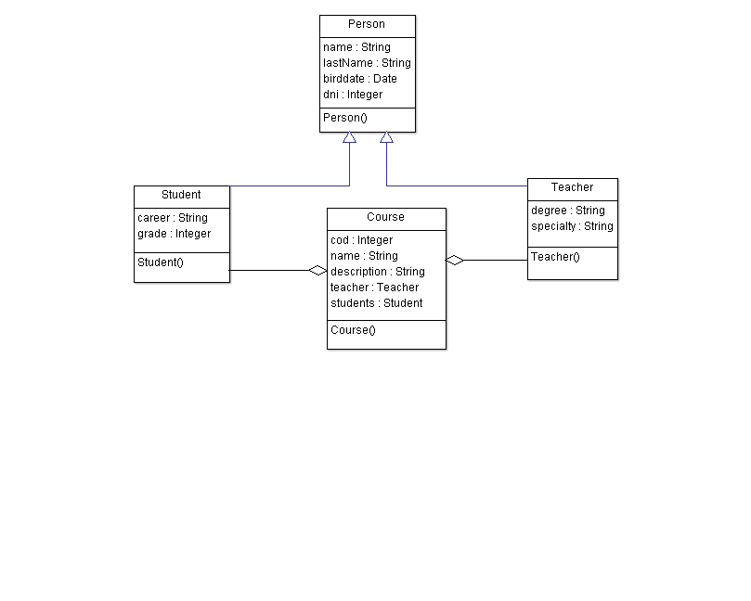

**Requirements:**

**inheritance and polymorphism**

• base class:

• child classes

**collection of references**

The class "Course" contains an ArrayList of the class "Student"

**Polymorphism**

Polymorphism will be used since objects of derived classes are processed.

**read and write class data to a file**

Files will be used to read and write data of the classes: Teacher, Student, Course.

**Exceptions**

Exception handling will be used for data validation and to handle any errors that occur while reading or writing.